**­­­**

Class 8

**Lecture \***

**Digital Electronics**

**(Binary Arithmetic)**

**Digital Electronics**



**Lab Objectives:**

* Binary Arithmetic
* Binary Addition.
* Binary Subtraction
* Binary Multiplication

**Binary Arithmetic**

## Binary Addition

It is a key for binary subtraction, multiplication, division. There are four rules of binary addition.

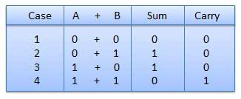

In fourth case, a binary addition is creating a sum of (1 + 1 = 10) i.e. 0 is written in the given column and a carry of 1 over to the next column.

### Example − Addition

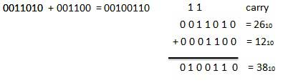

## Binary Subtraction

Subtraction and Borrow, these two words will be used very frequently for the binary subtraction. There are four rules of binary subtraction.

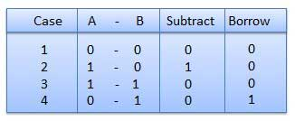

### Example − Subtraction

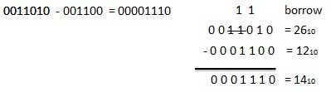

## Binary Multiplication

Binary multiplication is similar to decimal multiplication. It is simpler than decimal multiplication because only 0s and 1s are involved. There are four rules of binary multiplication.

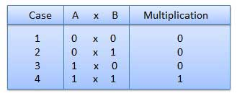

### Example − Multiplication

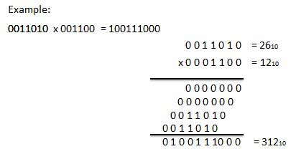

## Binary Division

Binary division is similar to decimal division. It is called as the long division procedure.

### Example − Division

